13. ReactJS-HOL

**Solution:**

Step 1: Creating the React App named “**bloggerapp**” using the npm command:

[**npx create-react-app bloggerapp**]

Step 2: **Creating Components** in a separate folder (components) under src folder:

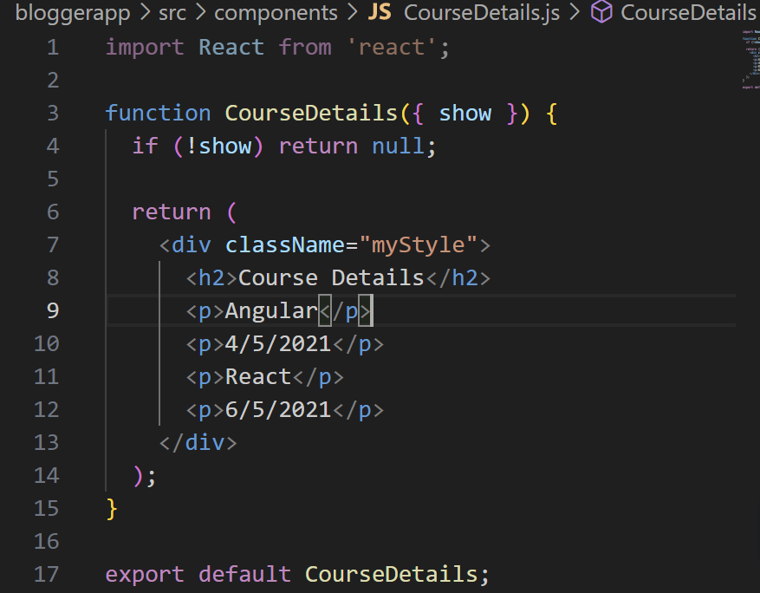 **a). CourseDetails.js:** shows course info

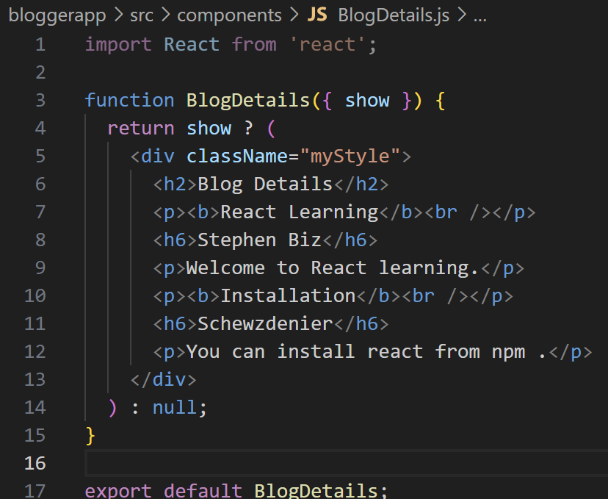 **b). BlogDetails.js:** shows blog contents

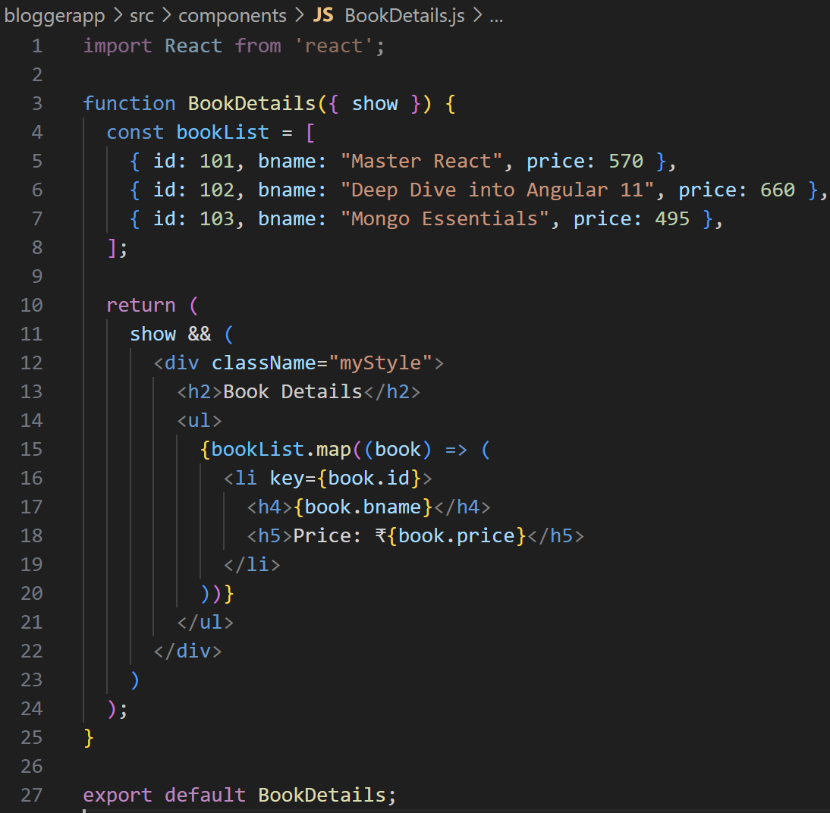 **c).** **BookDetails.js:** shows a list of books with prices

-Each component demonstrates **different types of conditional rendering** in React (if, ternary, &&).

Step **3**: Modifying **App.js:** Central place to combine and control all three components using boolean flags.

- for setting true/false values to **showCourses**, **showBooks**, and **showBlogs**

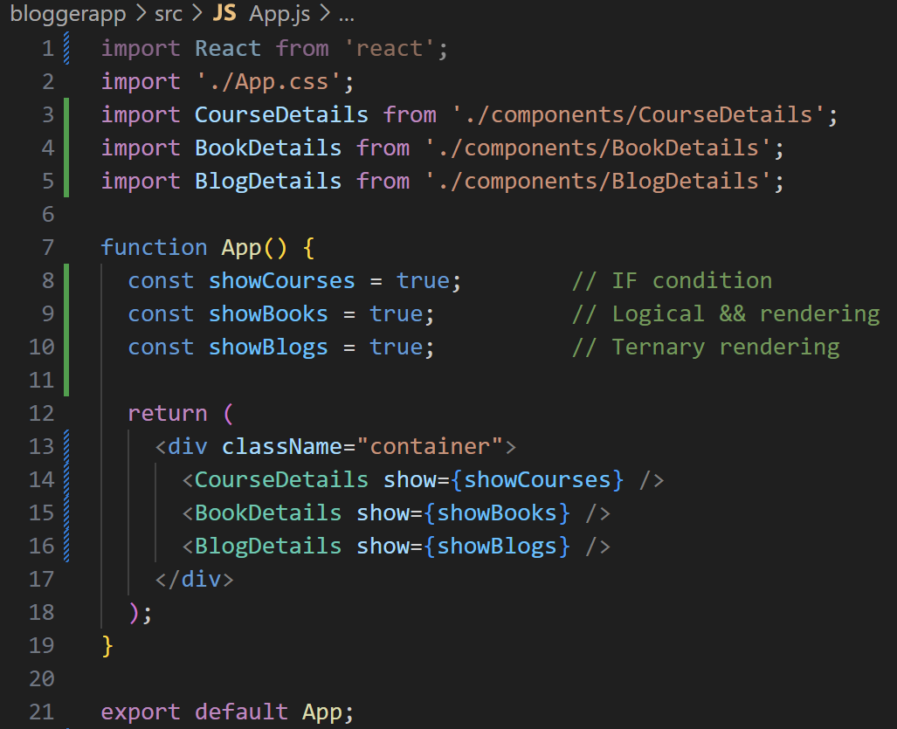 - These values are passed as props to each component to control their rendering.

Step **4**: **Styling** the final page **with App.css:** Makes the UI clean and structured.

- Flexbox layout for horizontal alignment

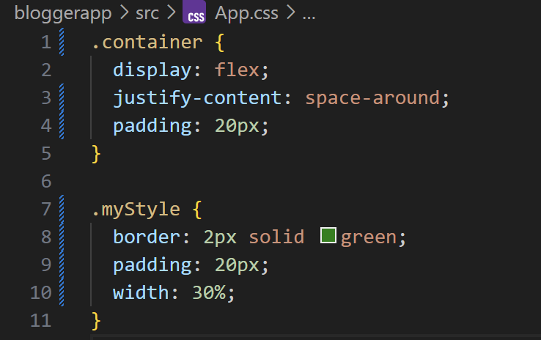 - Green borders and padding for each section

Step **5: Run** the application using 🡪 npm start



